


Team 6

Team Members
Name | BN | Sec
Mohamed Ashraf | 48 | 2
Mazen Adel | 47 | 2
Nesma Osama | 59 | 2
Mohamed Khater | 53 | 2

Problem

Problem Definition
The goal of this project is to develop a regression model that predicts the salary of a job in the field of artificial intelligence based on features such as experience level, company size, role, and so on.

Motivation
Salary expectation is a desirable issue because it helps people know which jobs can earn high wages, and it also helps students determine the role they should study. There are also people who may accept a salary lower than their rights if they do not know the expected salary.

Evaluation Metrics
- RMSE
- R²

Dataset Link
Global AI & Data Jobs Salary Dataset

Workload
Name | Work
Nesma Osama | Analyze dataset and Visualizations
Mohamed Ashraf | Preprocessing, Adaboost
Mazen Adel | Lasso Regression, Ridge
Mohamed Khater | DecisionTreeRegressor, RandomForest,

Results

Dataset Analysis

Information
- Rows:90000
- Columns:35
- Missing :0
- Duplicate rows:0
- Num of categorical columns:8
- Num of numerical columns:27
- Target column: salary usd
- There is an id column

Splitting
- Number of Training rows: 81000
- Number of Testing rows: 9000

Ordinal Data
- Company size: Startup <Small <Medium <Large <Enterprise
- experience level: Entry <Mid <Senior <Lead

Nominal Data
- country
- job role
- ai specialization
- education required
- industry
- work mode

Visualizations Results

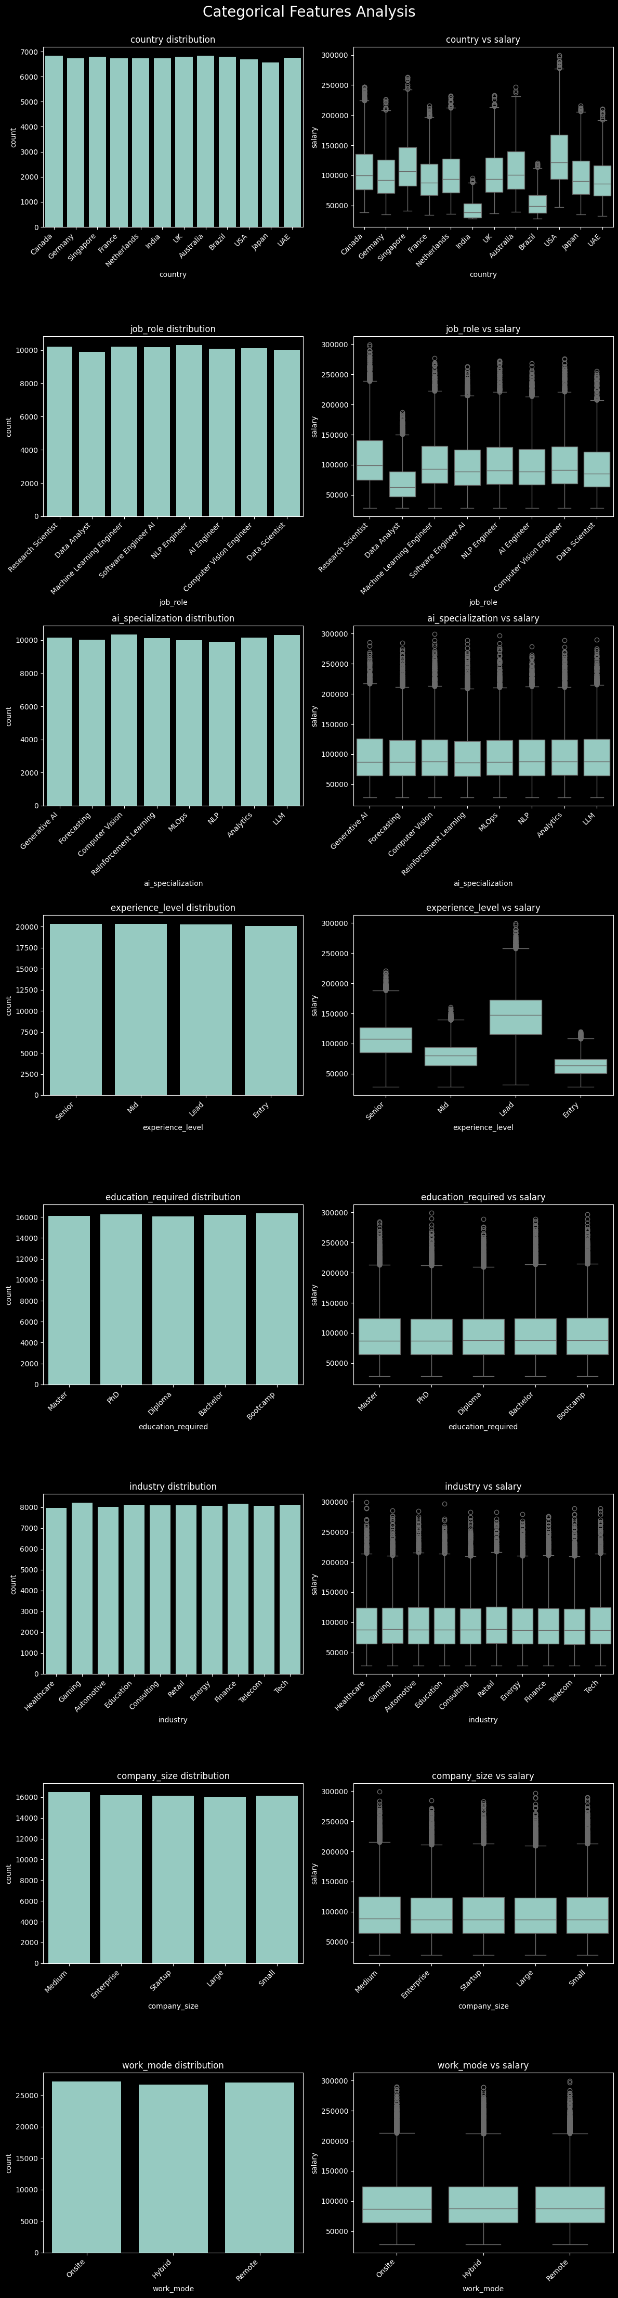
Categorical Features




Numerical Features
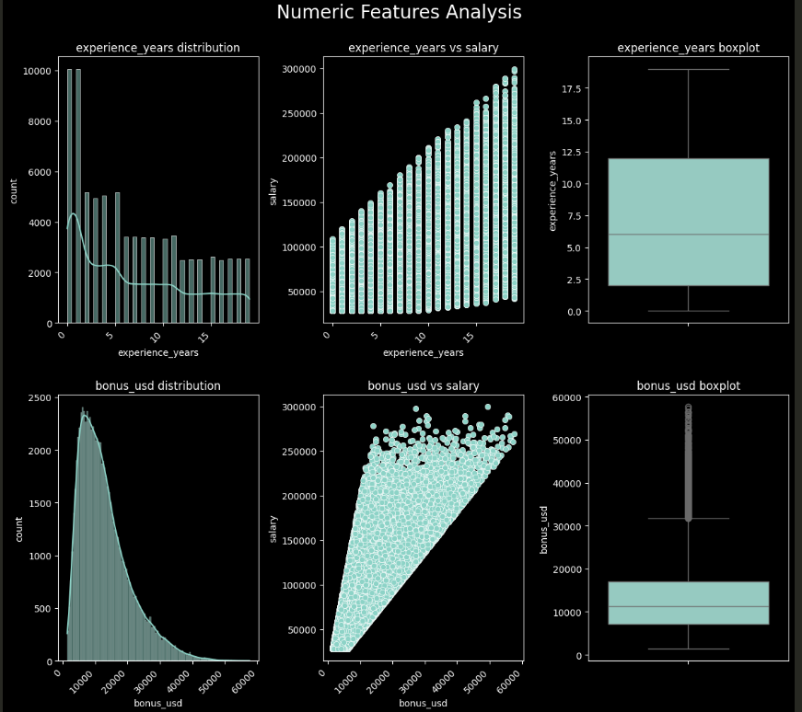

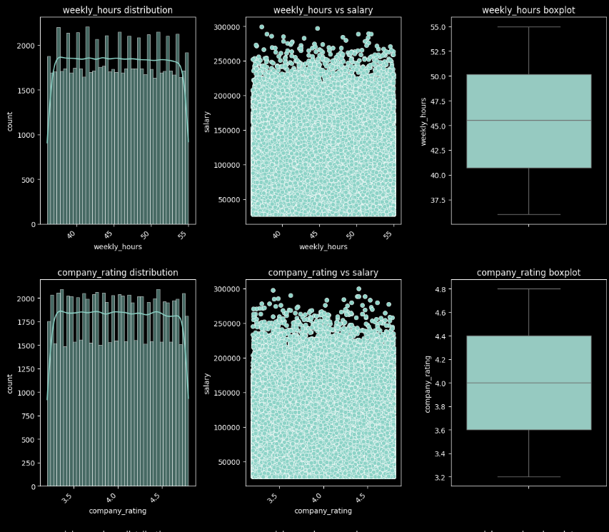
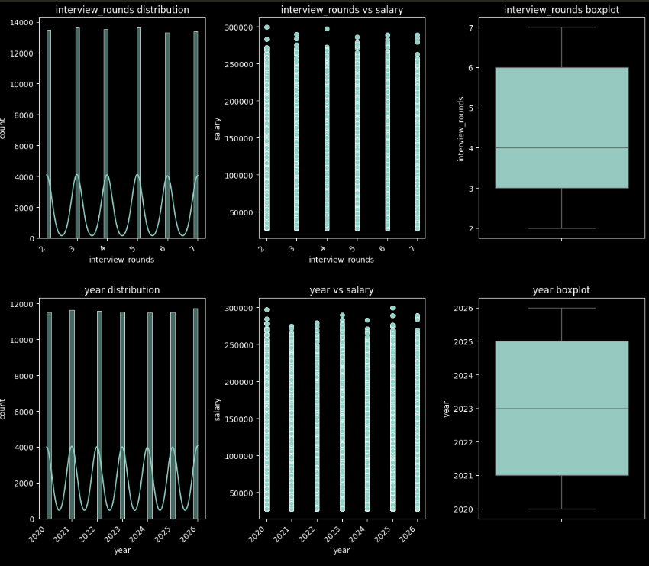

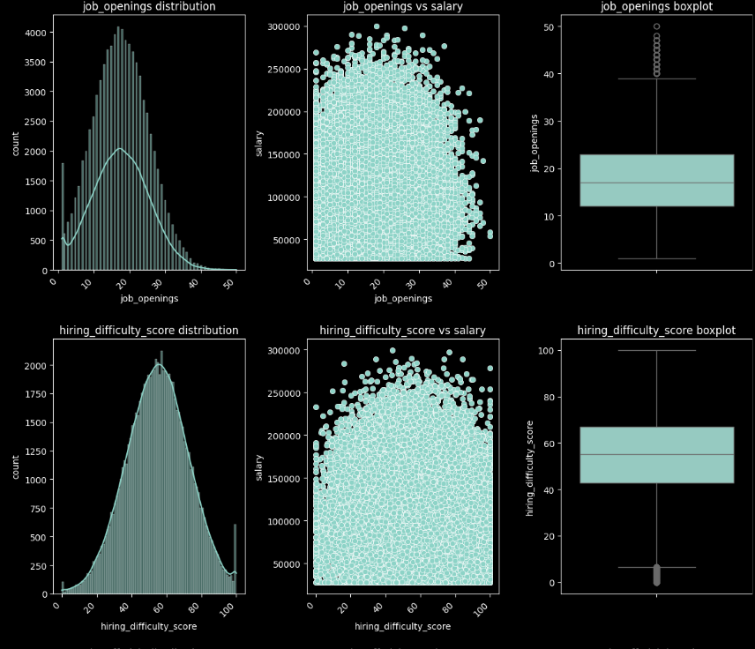
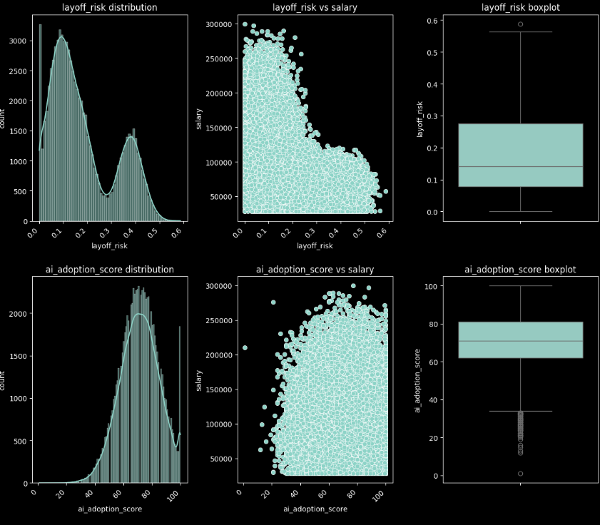
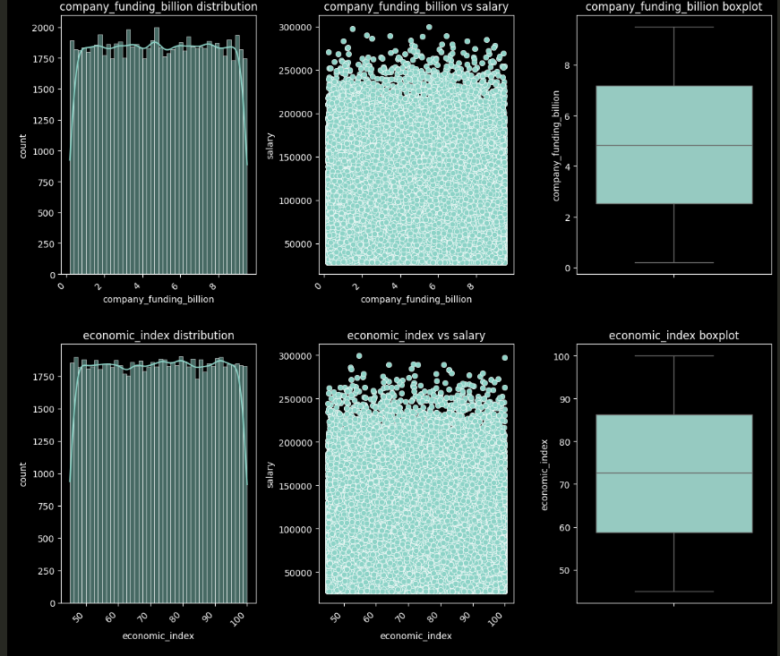
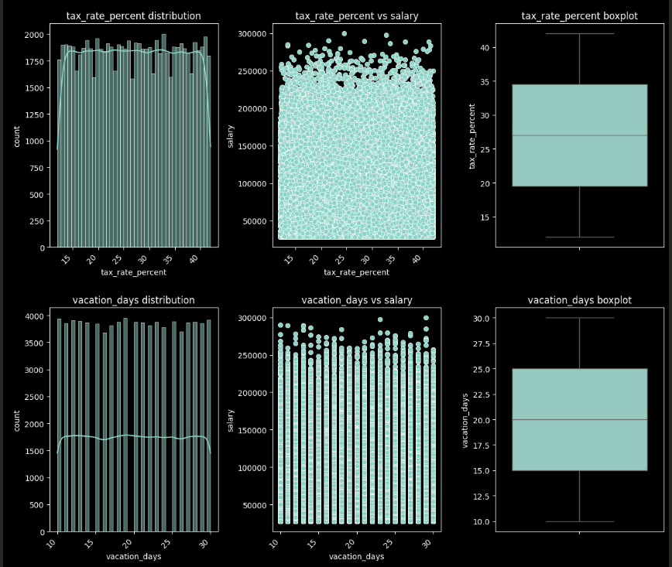
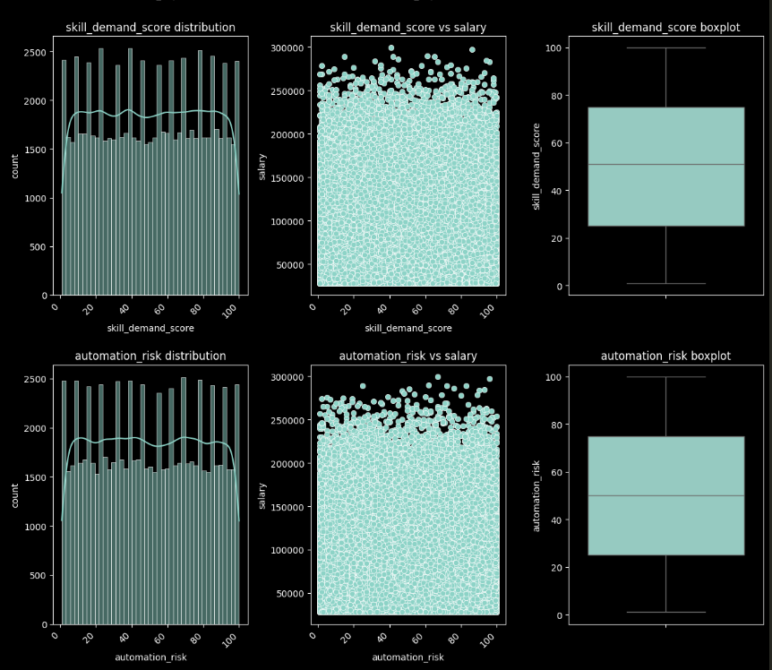
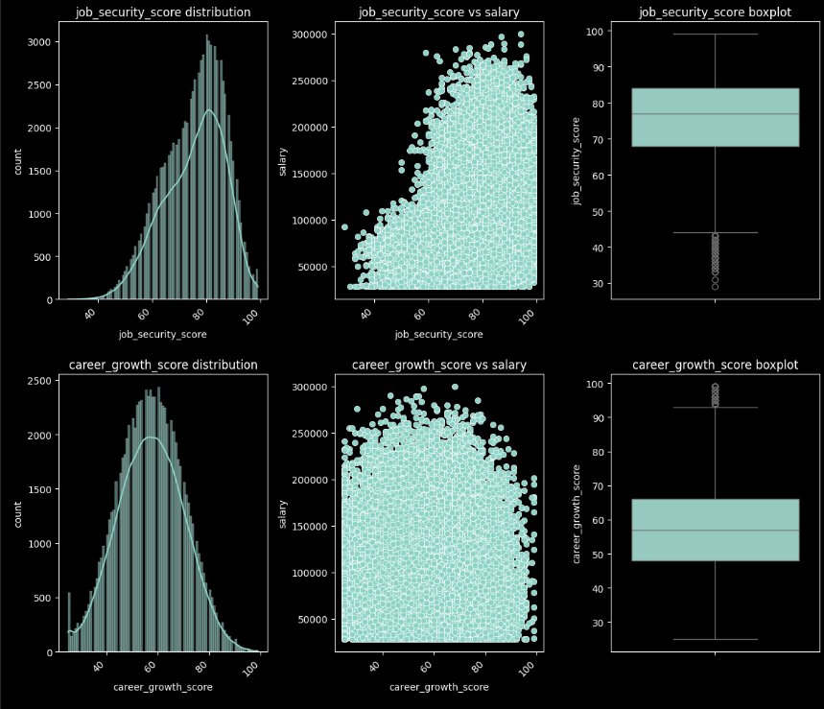
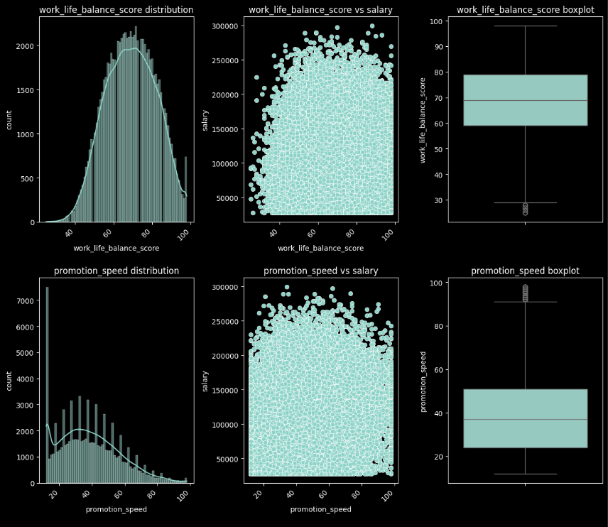
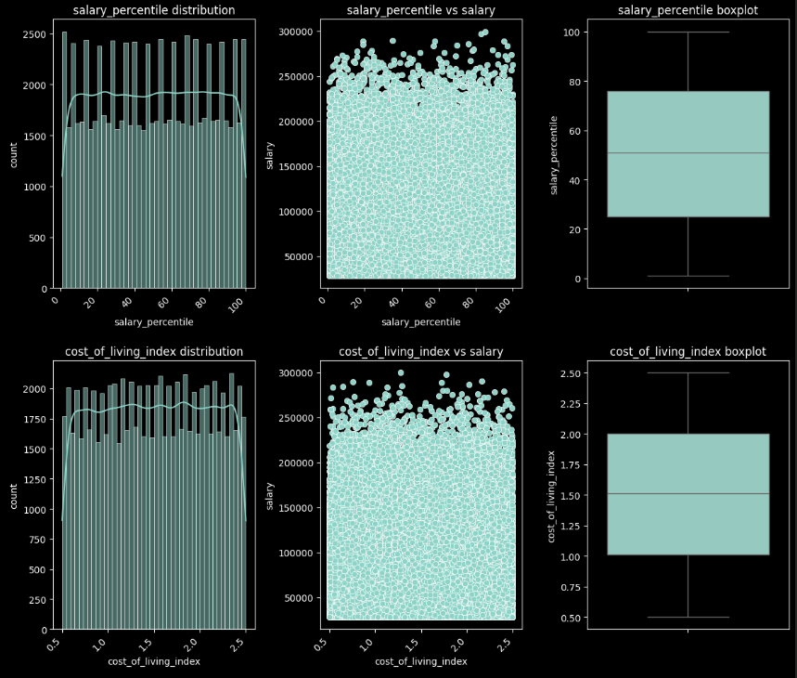
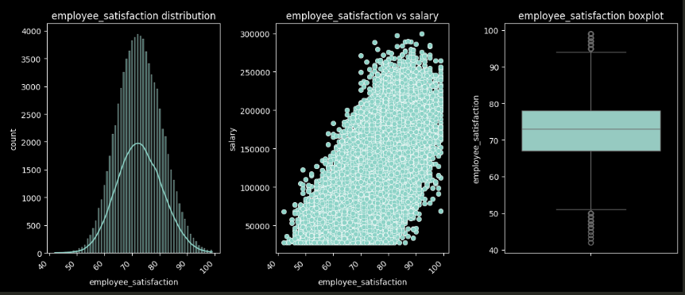

Target

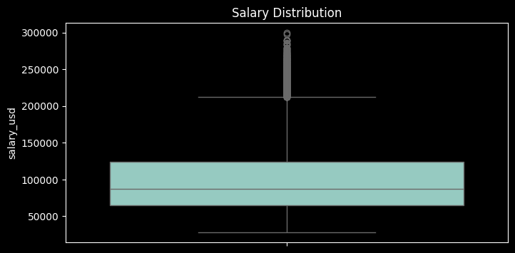Correlation
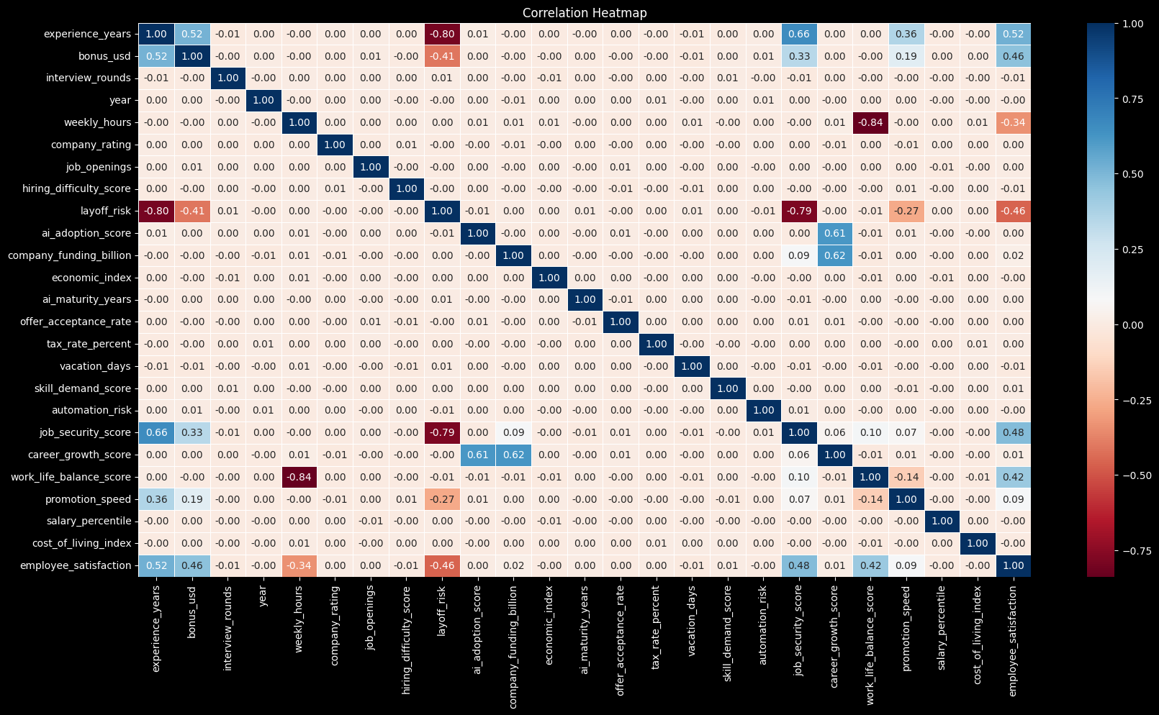
- Between numerical features

- Between numerical features and target
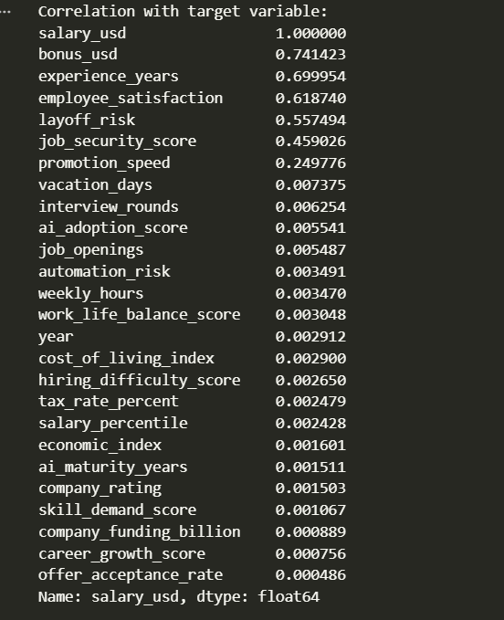

Experimental Results
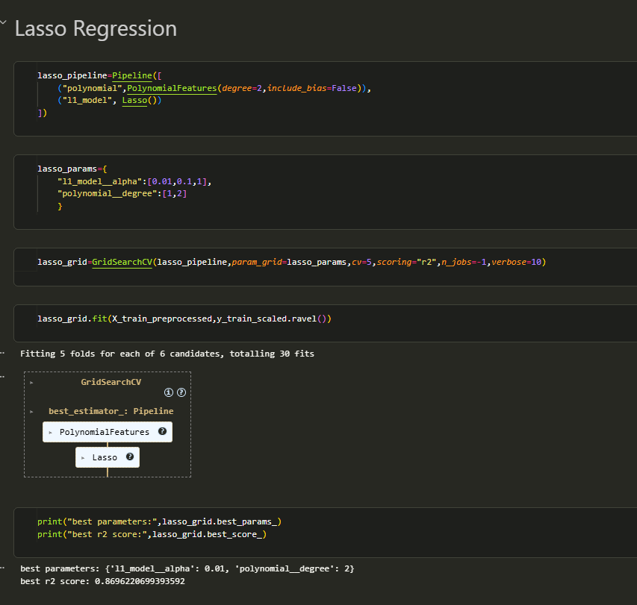
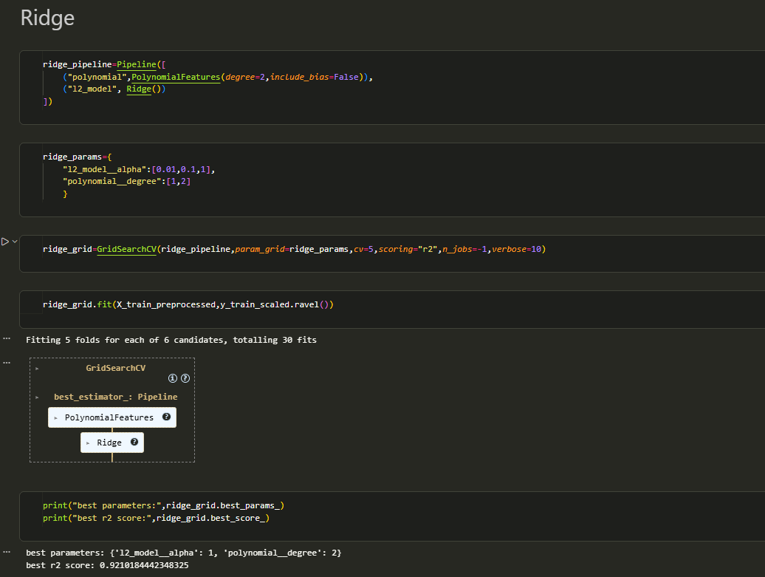
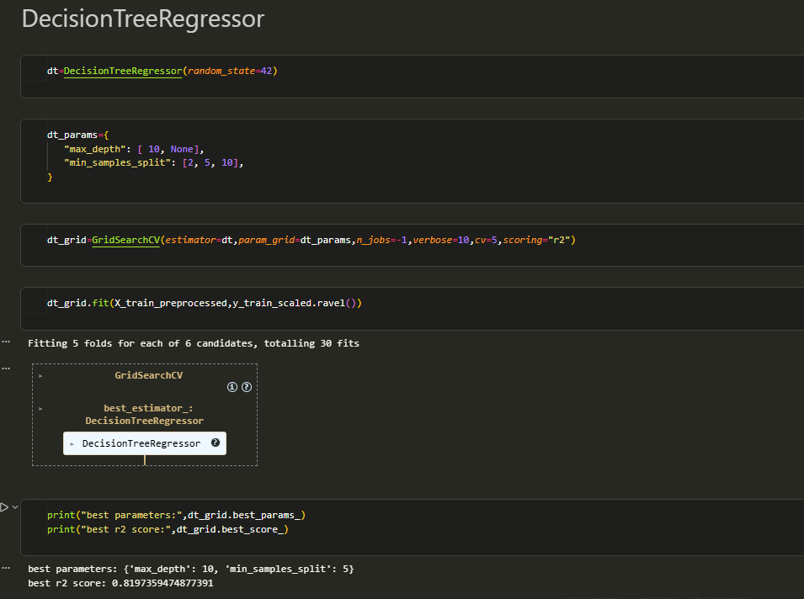
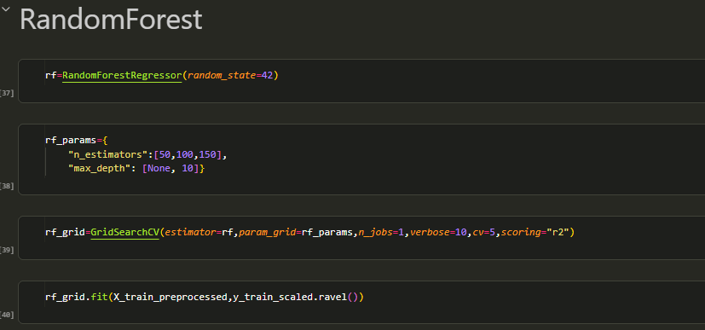
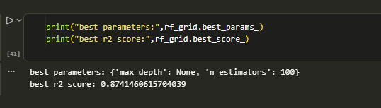
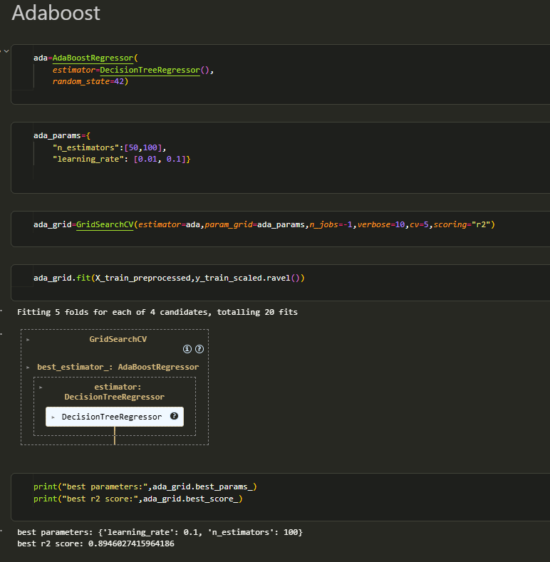

Discussion
For each model to get hyper parameters we used Grid Search CV with k=5
For
- Polynomial Features Lasso
This result indicates that introducing polynomial features improved model performance, suggesting that the relationship between the input features and the target variable is nonlinear. Also, the selected small regularization value suggests that stronger regularization was not beneficial for the l1 regularization with this data
- Polynomial Features Ridge
This result indicates that introducing polynomial features improved model performance, suggesting that the relationship between the input features and the target variable is nonlinear. Also, the selected large regularization value suggests that stronger regularization is good for l2 regularization.
- Decision Tree Regressor
The optimal depth being 10 suggests that the underlying relationships in your data are moderately complex min samples split 5 means Internal nodes must have at least 5 samples to be split further.
- Random Forest
To improve the result of Decision Tree Regressor, use random forest because Random Forest averages many deep trees, reducing variance while keeping bias low. number of estimators = 100 and it improve r2 score to .87
- Ada Boost Regressor
Same reason is for random forest, but AdaBoost works by sequentially training models that focus on previous errors. While effective

Conclusion

Model | R2 score
Polynomial Features Lasso | 0.869
Polynomial Features Ridge | 0.921
Decision Tree Regressor | 0.8197
Ada Boost Regressor | 0.894
Random Forest | 0.874

The best model when using Grid Search cross validation with k=5 is Polynomial Features Ridge
So use this model with the test dataset
